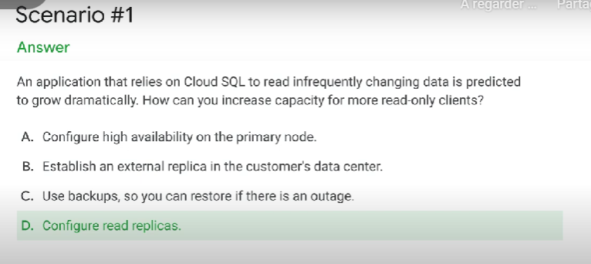

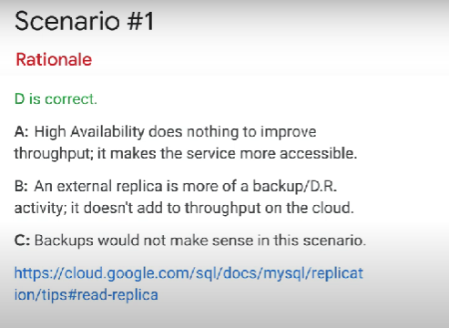

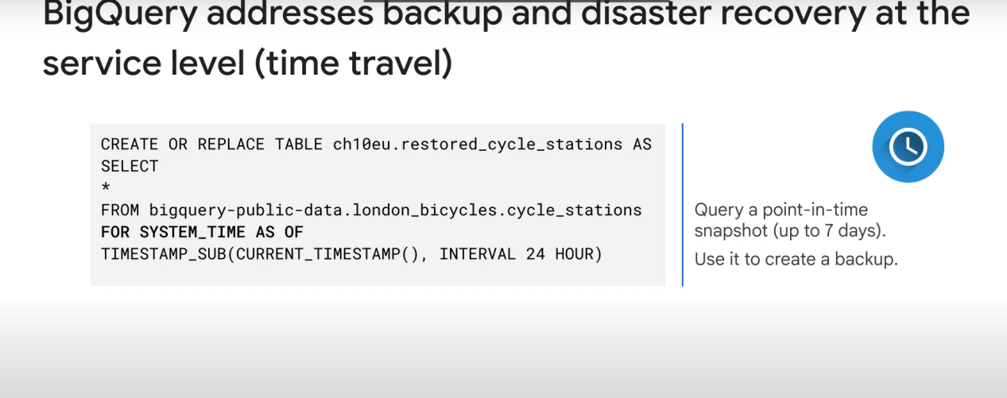

Google cloud pricing calculator can be used with BigQuery to estimate the cost of a query.

+

Query validator estimates about how much data will be used by the query. Use this data on the pricing calculator to get an idea of the cost

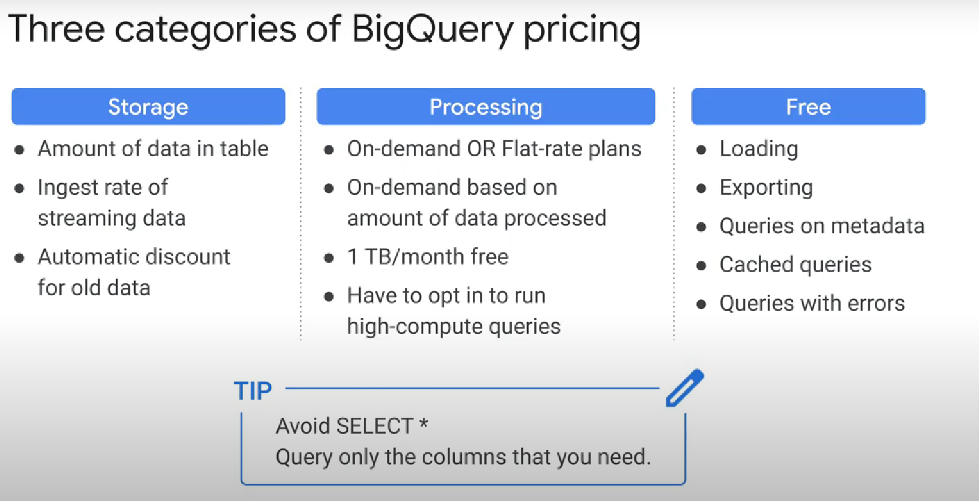

When you enroll in flat-rate pricing, you purchase dedicated query processing capacity, measured in BigQuery slots (cpu, memory, & network).

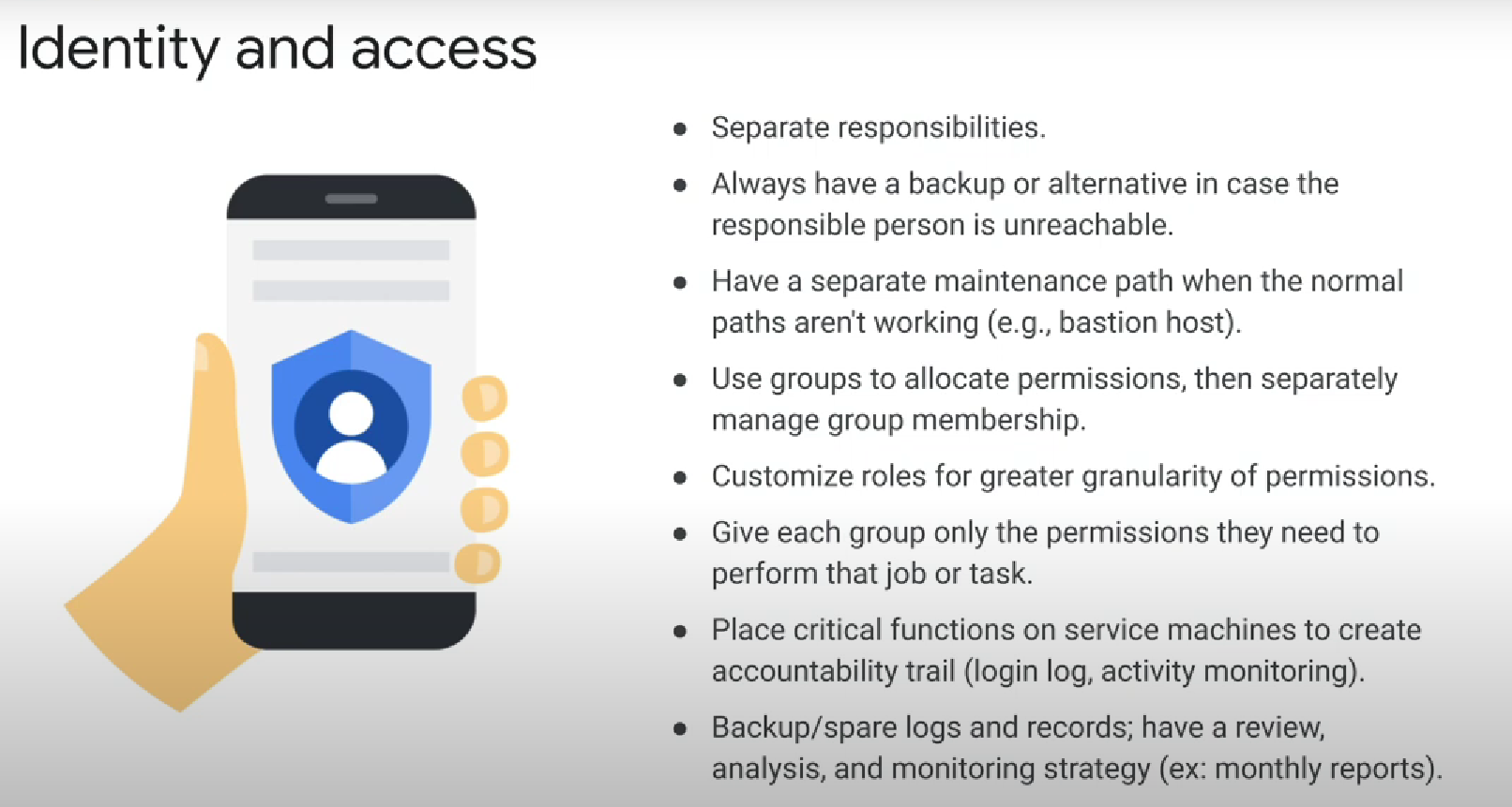

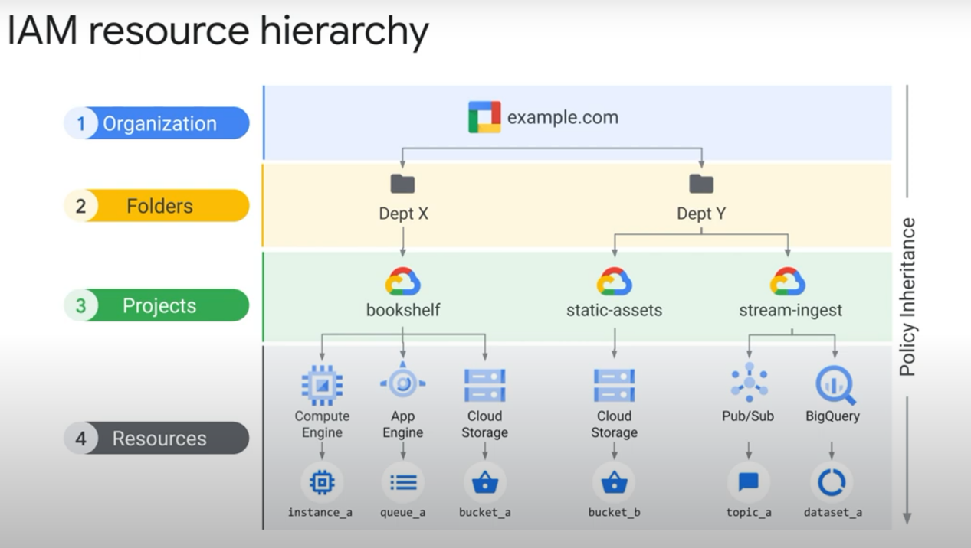

the final policy is the union of the parent policy and the resource policy what happens when these two policies are in conflict

what if the policy on the resource only gives access to a singlecloud storage bucket and restricts access to all other buckets however at the project level a rule exists that grants access to all buckets in the project

Answer: if the **parent policy is less restrictive** it **overrides** a more restrictive resource policy

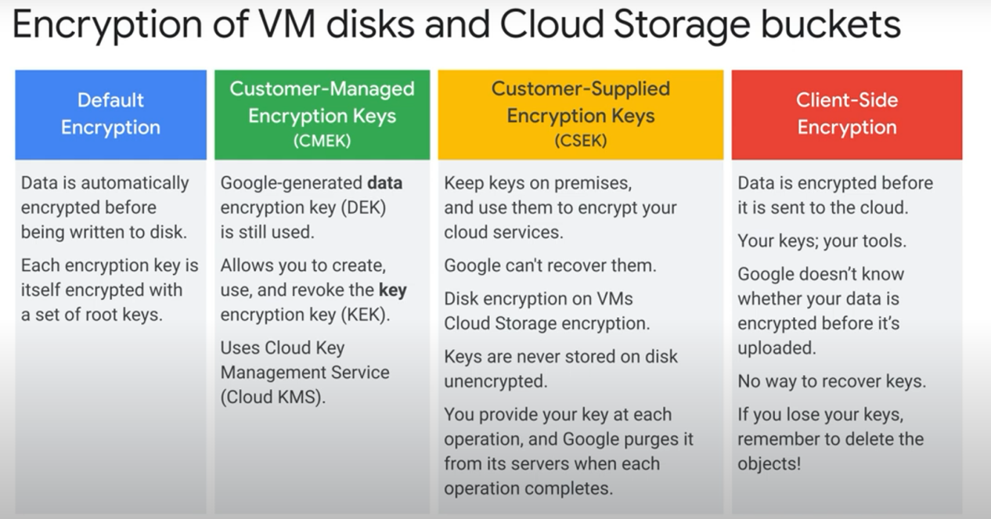

key concepts

* cloud armor: a service that protects from Ddos

* cloud load balancing

* cloud firewall rules

* service accounts separation into front end and back end

* isolation of resources using separate service accounts between services

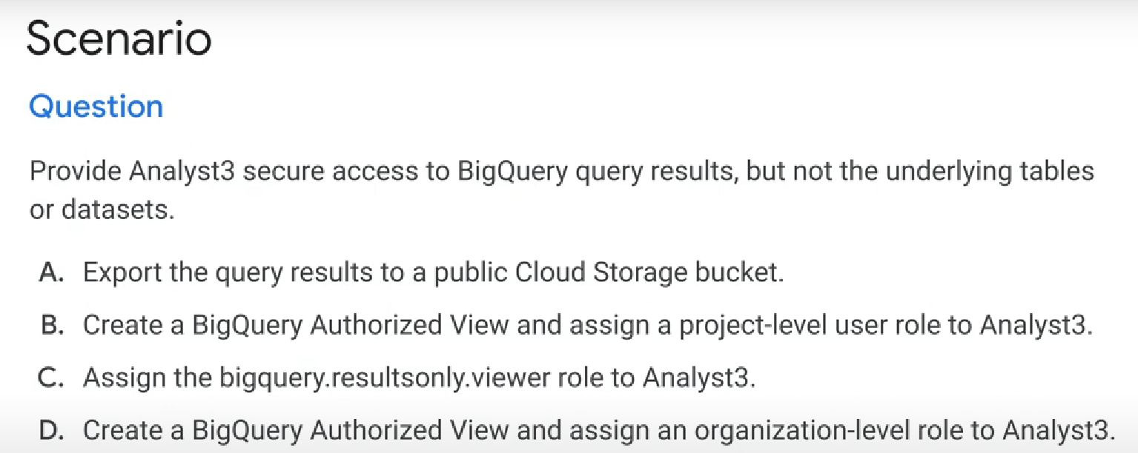

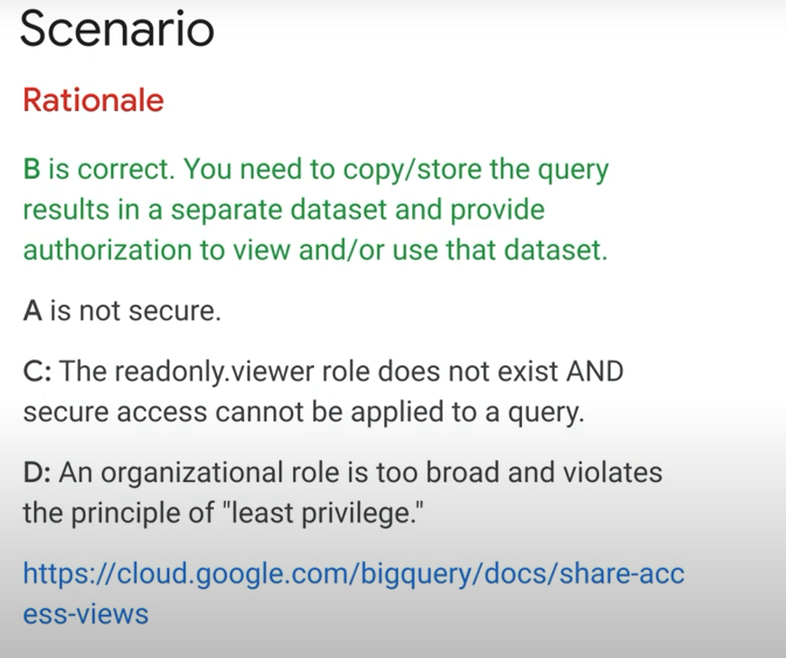

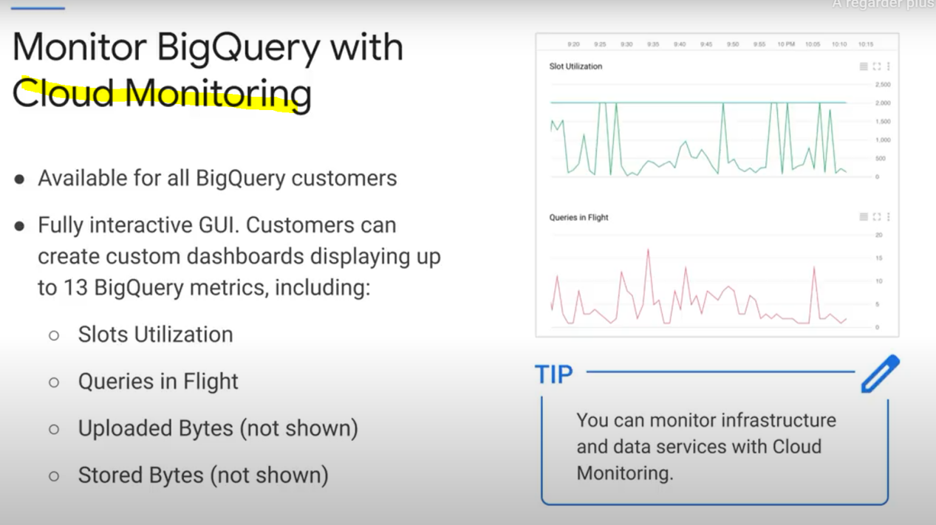

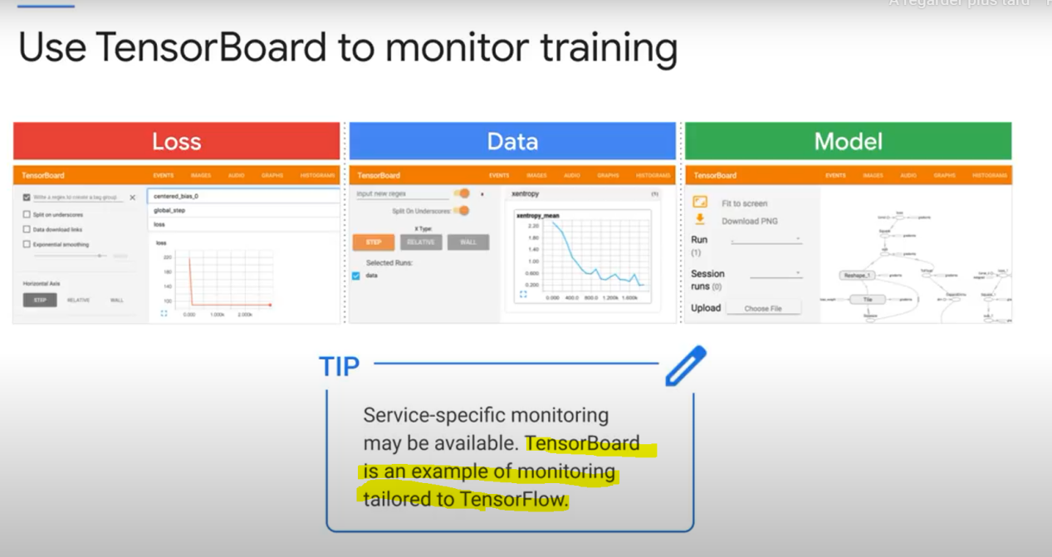

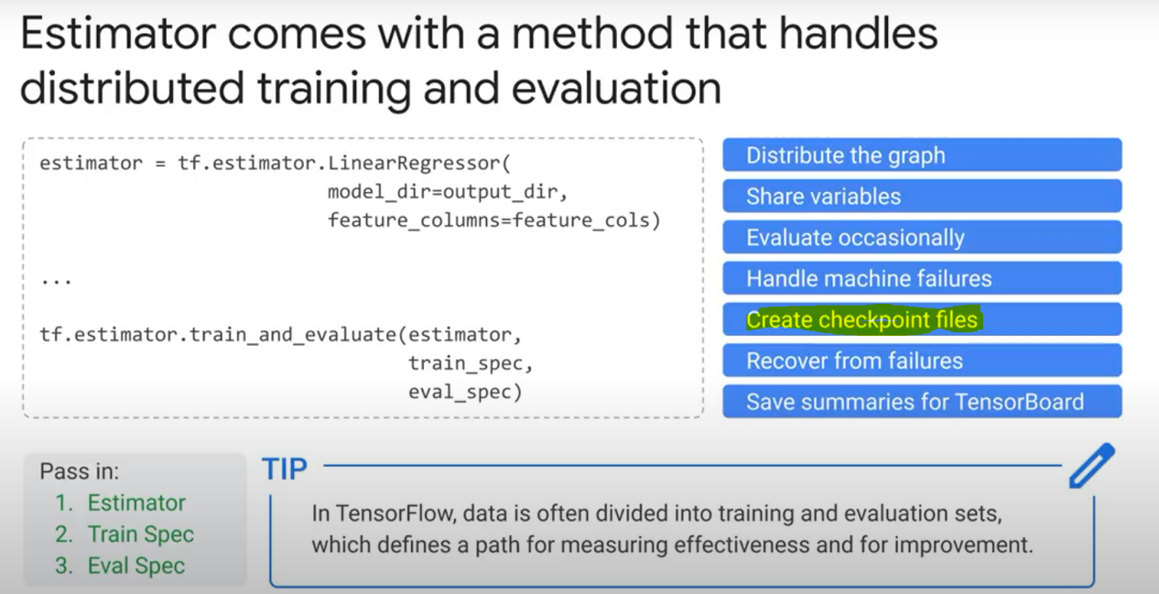

**Data protection (advocating policies):**

* We can use **Data Catalog** to create a **Tag** that we will assign to certain column(s) containing personal information that we need to protect (pii)

Note: We can’t directly add a tag in bigquery to a specific column, as native bigquery tags are added to the entire table

You can use **«DLP» (cloud data loss prevention)** helps you discover sensitive data in datasets/tables.

Official definition: Data security -- DLP -- Cloud DLP allows you to minimize what you collect, store, expose, or copy. Classify or automatically redact sensitive data from text streams before you write to disk, generate logs or perform analysis.

**De-identify** data: replace sensitive data with asterixes

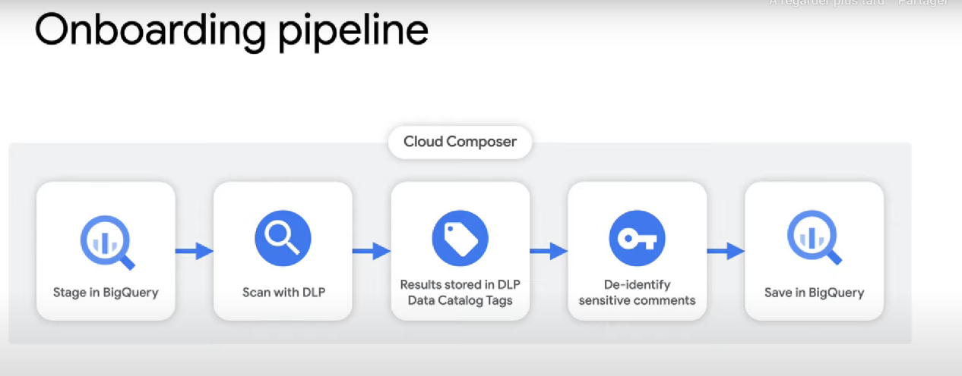

With data catalog, we can add a «clearance level» policy tag on specific column. It can have many values (E.g: low, medium, high). Then, any person who needs to read a column with a certain clearance (E.g: high), will need to be assigned the «fine-grained reader» role to the «High» ressource in data catalog.

You can also create a **row policy** that only allows certain readers to read rows with certain column/value pairs. E.g:

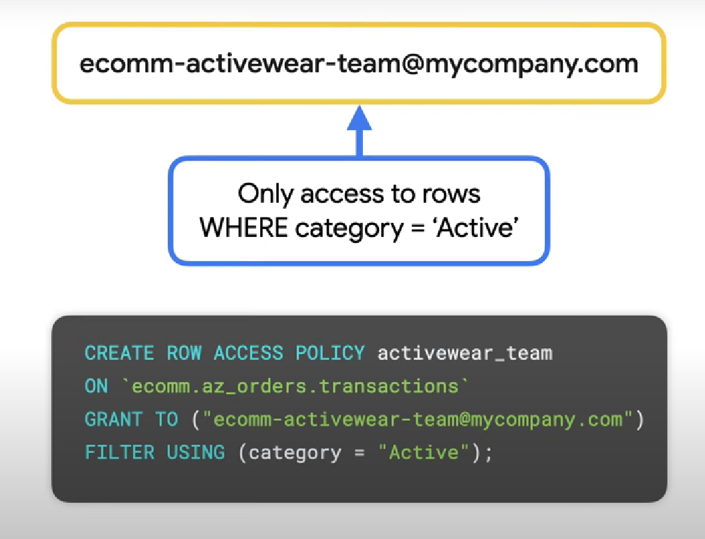

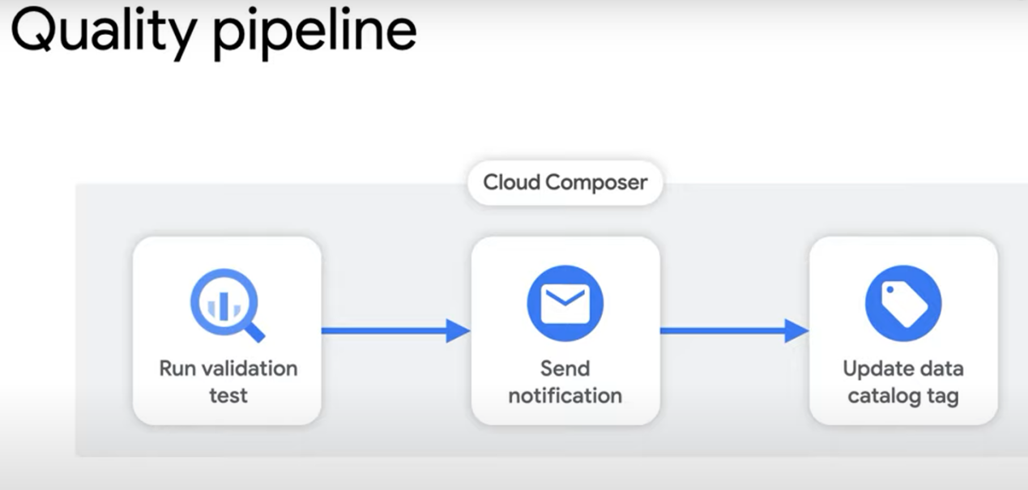

(data catalog is used here to add tags about data quality/validation to the processed data)

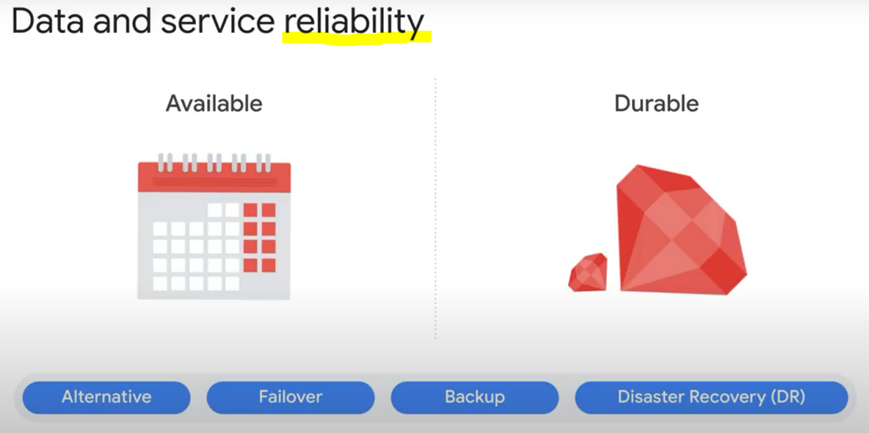

* Automatic failover consists of automatically moving data or applications to the standby server if the primary system fails.

* The alternative is a passive system where the process happens manually. Most failover processes operate automatically to reduce downtime.

* Backup and DR (disaster recovery) are the slowest. If we’re in a system that requires atomic transactions, we cannot accept these!

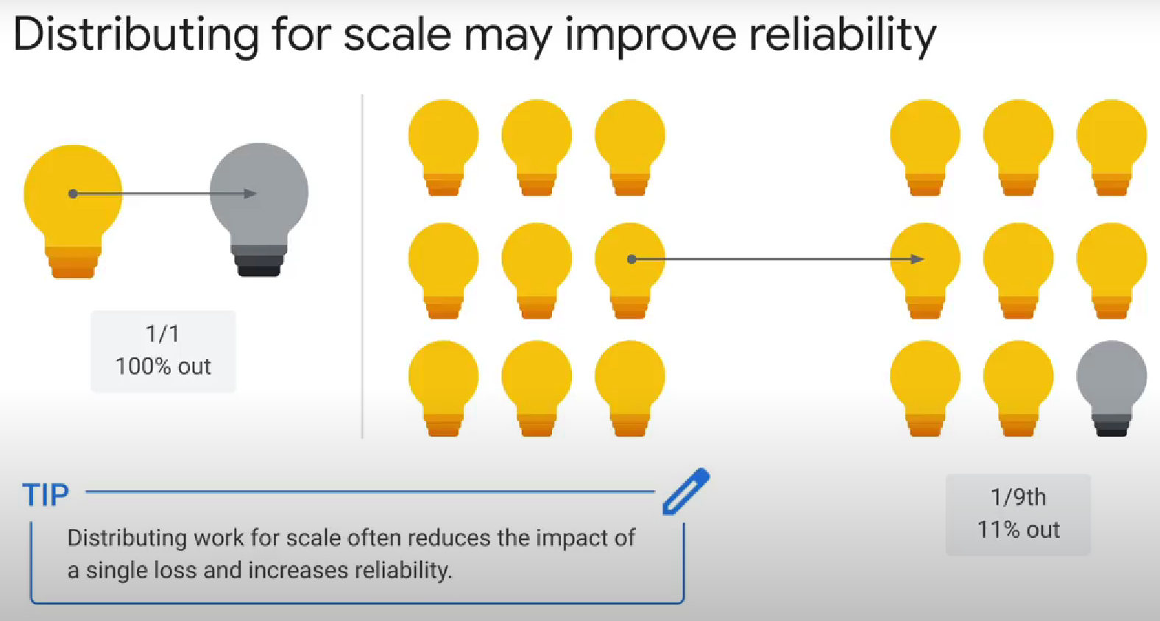

Google Cloud's operations suite = Cloud monitoring + Cloud Logging

Getting rid of duplicates when each row has an ID column, using a SQL query:

Use ROW_NUMBER(Partition by ID, ORDER BY ID) as rowNumber, then add WHERE rowNumber = 1 (it starts at 1 not 0)

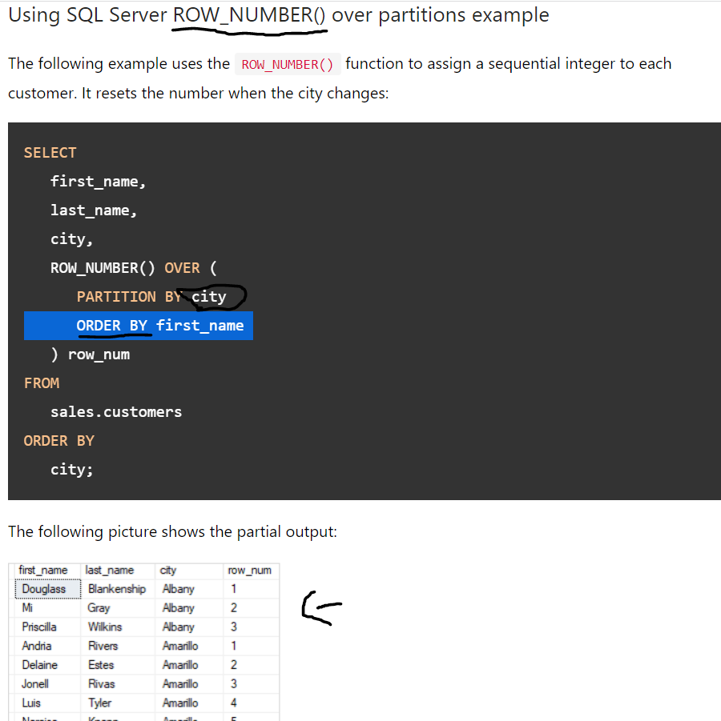

Lag function

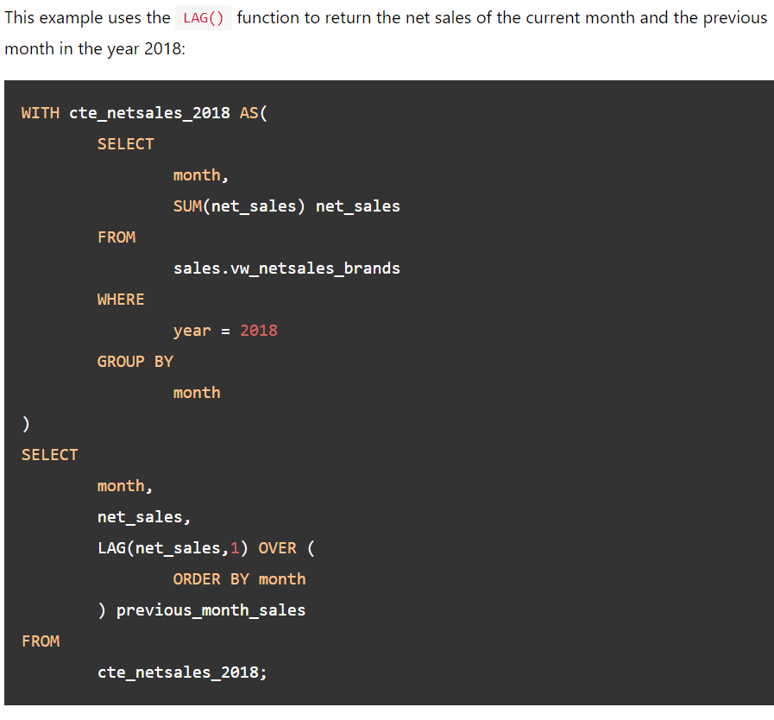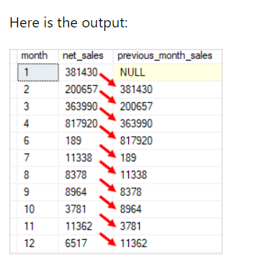

(get 1 column from the nTH previous row (offset = n))

LEAD is the opposite of LAG

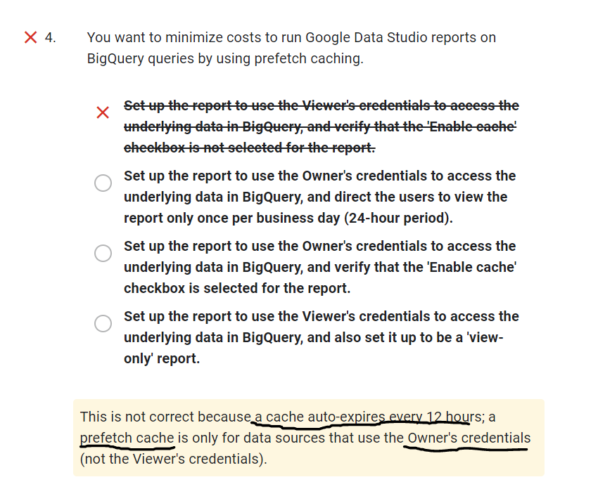

- **Avoid self-join at all cost** because that's what google says.

- **Adding additional compute resources is not a recommended way to resolve database schema problems.**

- For real-time data on Google Data Studio, disable caching by editing **the report settings (not bigquery’s)**

**- Cloud SQL** doesn’t auto-scale CPU power. It can only autoscale memory/storage.

- **Google Cloud Datalab** is used for data vizualization and ML. You can deploy it in a VM on GCP.

- 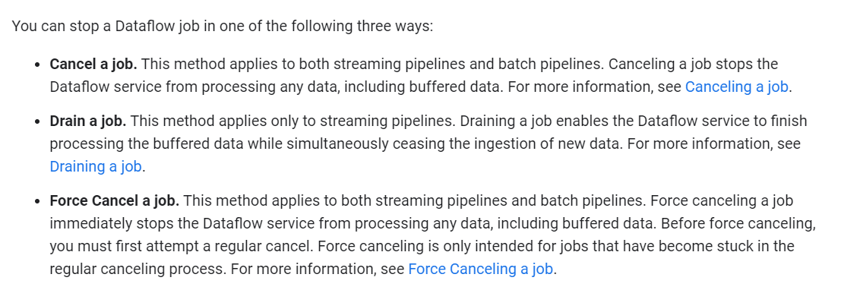

Use the -drain flag when cancelling/replacing a dataflow job with another one to avoid losing data

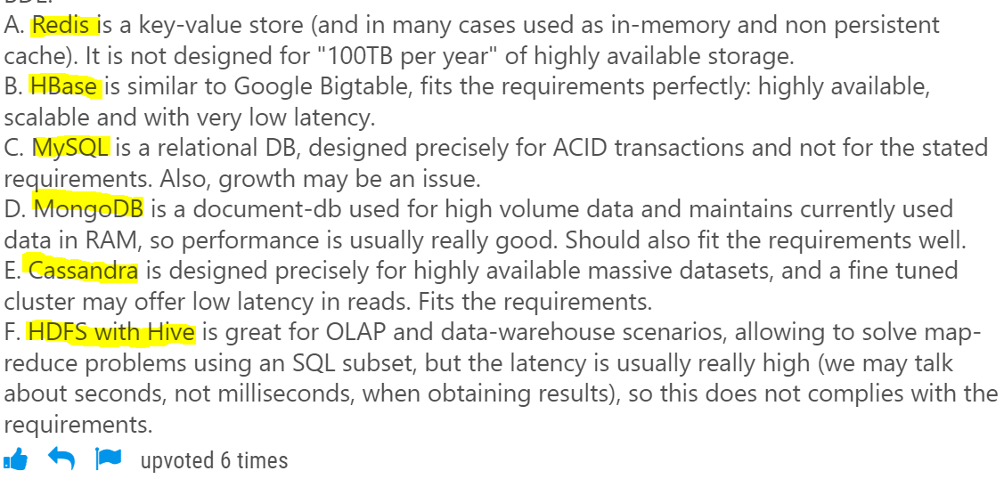

- Less complexity in ML model (less features, less layers, etc) + increasing regularization parameters (L1 & L2) = less risks of overfitting

- 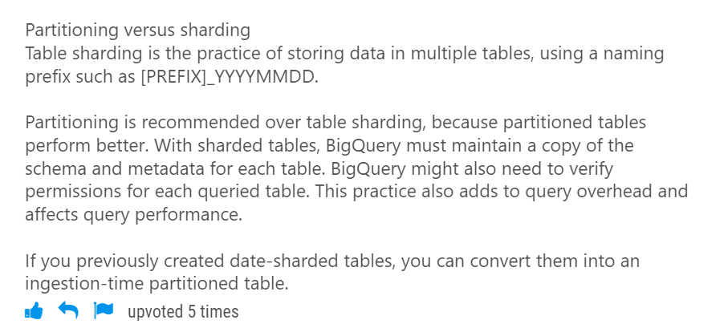

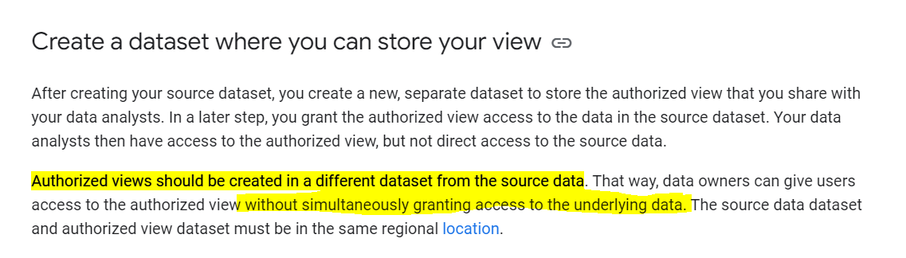

- **BigQuery Reservations** enable you to switch between on-demand pricing and flat-rate pricing

After you purchase slots, you can assign them to different buckets, called reservations. Reservations let you allocate the slots in ways that make sense for your particular organization. Jobs that require high SLAs will take priority to use the reserved slots.

**Need-to-study if I have time:**

- HIPPA, COPPA, FedRAMP, GDPR policies (data protection)

- Partitionning VS clustering in bigquery?

Clustering is the same as partionning, but you can use any column type (text, number, etc...), not only timestamps/datetime/number like in partionning. Also, note that your table can have a maximum of 4 clustered columns per table, and that the order of the columns (which column we cluster first) is very important for query performance: always cluster the most queried/filtered by column first.

- partition expiration dates?

When you create a table partitioned by ingestion time or time-unit column, you can specify a partition expiration. This setting specifies how long BigQuery keeps the data in each partition.

- TODO: read about SIGNED URLS

- TODO: LEARN ABOUT THE IAM ROLES

- IOT Core :

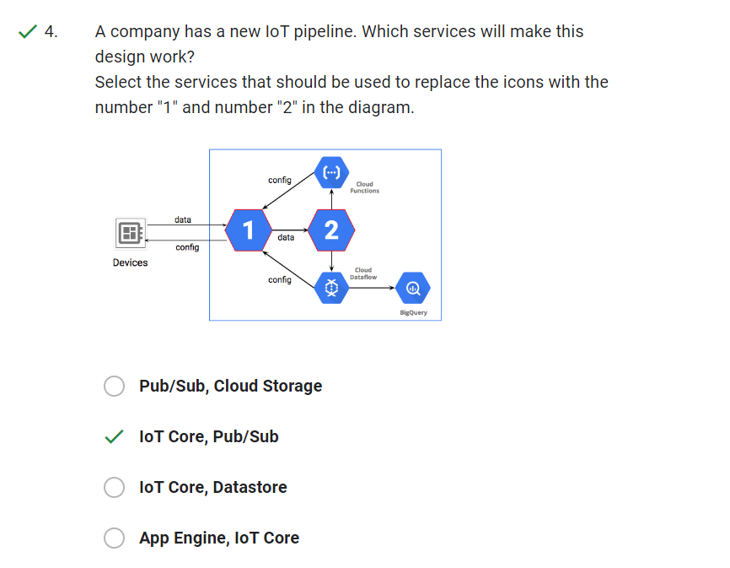

- Cloud Router with VPN:

* Cloud VPN (public internet), VS direct peering VS Partner/Dedicated interconnect

* Cloud VPN securely connects your peer network to your Virtual Private Cloud (VPC) network through an IPsec VPN connection. Traffic traveling between the two networks is encrypted by one VPN gateway and then decrypted by the other VPN gateway. This action protects your data as it travels over the internet. You can also connect two instances of Cloud VPN to each other.

- Partner VS direct interconnect:

**Dedicated Interconnect** provides a direct physical connection between your on-premises network and Google's network. **Partner Interconnect** provides connectivity between your on-premises and VPC networks through a supported service provider.

Note: If your traffic doesn't require a 10-Gbps or 100-Gbps circuit, consider **Cloud VPN** or **Partner Interconnect** instead of a dedicated interconnect.

Note 2: For partner interconnect: more points of connectivity through one of our supported service providers. Traffic flows between networks through a service provider, **not through the public internet.**

-Cloud Spanner, interleaving tables to optimize join queries:

Interleaved tables: 1 table is the «parent», the other is the «child», and they are stored in the same place. Therefore, the join queries you use on the 2 tables will be very optimized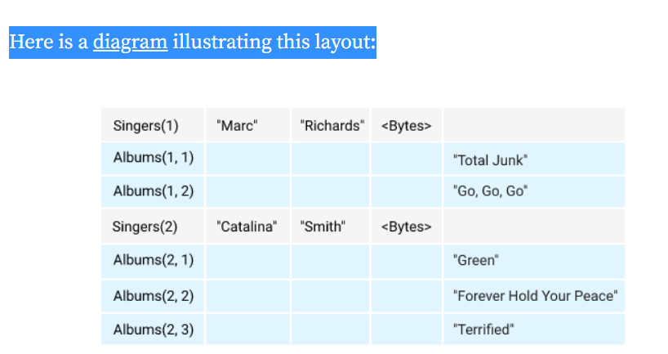

-Hopping Windows = Sliding

- Tumbling Windows = Fixed